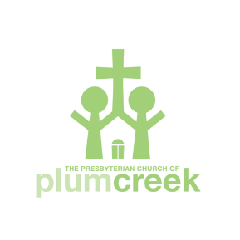

Liability Waiver

As a participant in the 2026 Plum Creek Scotland holiday, I the undersigned, hereby agree to take personal responsibility for my own actions and well-being. I will hold harmless the Presbyterian Church of Plum Creek, and Carpenter Holidays, Carolyn Leah, Ken White and Stephen Carpenter, their agents and subcontractors (hereafter called "organizers") who, except in case of gross negligence or malfeasance, shall not be held liable for any of the following: theft, loss, injury, illness, or damage to person or property; any inconvenience or unavoidable expense caused by circumstances beyond the control of the organizers: any fault, actions or inaction of any person or company engaged in conducting the activities of the pilgrimage or on the pilgrimage itself.

I certify that I will have adequate insurance to cover any injury or illness I may suffer while participating, or else I agree to bear the costs of such injury or illness myself. I further certify that I am willing to assume the risk of any medical or physical condition I may have.

I understand that while the organizers will do their utmost to fulfill the proposed itinerary, the variabilities of weather and world circumstances may require adjustment and modification to the schedule that would be in the best interests of the group.

I agree that I will abide by any rules currently in place in the UK regarding Covid at the time of the journey, will monitor my own health before and during the trip, and will test immediately if I suspect that I am infected. If I contract Covid or any other illness during my stay in the UK, I understand that any medical expenses and additional costs for hotels and/or extra transportation will be my own responsibility and will not be borne by the organizers.

Print Name________________________________________________

Signature__________________________________________________ Date_______________

